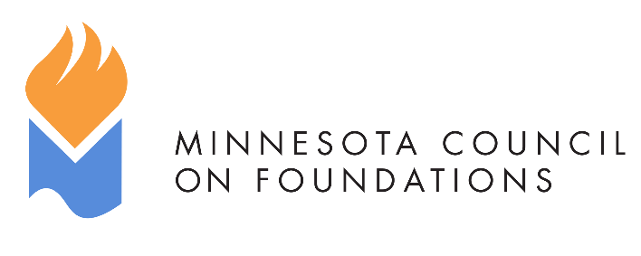
Minnesota Common Grant
Suggested Common Application
Sections and Questions

Before You Begin
We are pleased to introduce an updated version of the Minnesota Common Grant. A working group of Minnesota foundations and nonprofits developed the following common application sections and questions to make the grantseeking process simpler and more efficient for nonprofits.
Whether you are a funder or grantseeker, please read the full Instructions for Use.

SECTION I. Standard Profile Questions
Please complete the following information.
Note to funder: We encourage using resources such as impala or GuideStar to collect as much information as possible for this section. If your foundation wishes to automate the process and lessen the burden on potential grantees, Candid (the maker of GuideStar) offers APIs that can import information directly from GuideStar into many grants management platforms.

Data About the Organization
Full Legal Organization Name:
Address: City: State: Zip Code:
Website:
President/Exec. Dir. (Pronouns):
Contact Person (if different) (Pronouns): Title: Phone #: Email:
Year established:
Fiscal year end date: (month and date)
501(c)(3)? Yes/No
EIN #:
Are you using a fiscal sponsor? Please provide: their name, address, EIN, and contact information:
If you are using a fiscal sponsor, a funder may request additional attachments such as the sponsor’s budget and audit, as described below.

Data About the Grant Request
Request to:
Date of Application:
Type of support that is being requested: (General operating, Capital, Project/program, Other (describe)):
Dollar amount requested:
Length of request (one-year, multi-year, etc.):
Specific (INDIVIDUALIZED) questions for funder (i.e., grant opportunity name, category, region, etc)

SECTION II. Common Narrative Questions
The following questions allow nonprofits a flexible space to tell their story.
Q1. Request Summary (Please write a concise response. Most people write about 2 – 3 sentences. The maximum response is 400 characters.)
Q2. About Your Organization (Please share the most important information about your organization. Most people write about 3 – 5 paragraphs or about 2,000 characters. The maximum response is 3,000 characters or about one page.)
Note to applicant: Please share information about your organization. Relevant information could include some of the following:
- Your organization’s mission statement
- A brief organizational history
- Current programs and recent accomplishments or achievements
- Recent major changes to financial and/or organizational circumstances
- Current goals including any goals around Diversity, Equity, and Inclusion (DEI)
Q3. About Your Community (Please share the most important information about your community. Most people write about 3 – 5 paragraphs or about 2,000 characters. The maximum response is 3,000 characters or about one page.)
Note to applicant: Please share information about the community where, or with whom, you do your work. Relevant information could include some of the following:
- The community opportunity, challenge, issue or need that your organization works to address
- Information about the people you serve such as socioeconomic status, race, ethnicity, gender, sexual orientation, age, physical ability, and language
- Details about how you work with other organizations, coalitions, or networks
- Details about how you listen to/involve constituents, community members, and/or volunteers

Q4. About Your Impact (Please share the most important information about your impact. Most people write about 3 – 5 paragraphs or about 2,000 characters. The maximum response is 3,000 characters or about one page.)
Note to applicant: Briefly, please explain what success looks like overall and for any goals stated, above. How do you track impact and how do you know you’re moving toward it?

Q5. About Your Program/Project (Please share the most important information about your program/project. Most people write about 3 – 5 paragraphs or about 2,000 characters. The maximum response is 3,000 characters or about one page.)
(Please skip this section if you are applying for general operating support.)
Note to applicant: Please explain the program/project. It is not necessary to restate information answered above. Relevant information could include some of the following:
- What you plan to do (activities) and the timeframe
- Why you plan to do it (opportunity, challenge, issue or need)
- Who will be impacted (target population, including age, gender, ethnicity, other relevant characteristics)
SECTION III: Data About Demographics
Note to funder: You may choose to request demographic data about an organization’s leadership, board members, and/or staff. These data requests should include context such as: how you will use the data, why the data is being requested, and how the data will advance your goals. You are encouraged to share your own demographic data before requesting this information from grantee partners. Here is one good example of data transparency from the Sewall Foundation.
Note to applicant: Funders may ask you to share your demographic data or they may ask you to complete the data through Demographics via Candid. When you claim and update the demographic data section of your Candid profile, funders can view your demographic data. The full data set is described in this document: How to collect and share demographic data and includes information about: Role; Race & Ethnicity; Gender Identity 1; Gender Identity 2; Sexual Orientation; and Disability.
Demographic data requests must align with the format used by Candid. By using these same questions, we can increase consistency across the sector and decrease the need for nonprofits to provide demographic data in different ways which is a poor use of time and resources.

SECTION IV. Attachments
Note to funder: Please limit your application to the following standard set of requested attachments, or fewer. You may include these attachments along with the application. Or you may ask for these attachments at a later time, or not at all, based on your process and needs. Please do not request other attachments, which may provide redundant or publicly available data, such as an IRS Determination Letter.

- Board list with affiliations (By requesting this information as an attachment, nonprofits do not need to re-type this data into separate answer fields.)
- Organizational fiscal year operating budget (income and expenses) for the current year (any format will be accepted); budget should document how many FTE, if any, are included in any salary/benefits expenses.
- Audit or financial review from most recently completed year showing actual income and expenses. This information should include a balance sheet, a statement of activities (or statement of income and expenses) and functional expenses. Funders may request the most recent Form 990 tax return which may not be publicly available at the time of request.
- Project budget (income and expenses), if seeking a project grant, including projected source(s) of income for the grant period. A sample template will be included soon.
- Sponsor attachments: If a grantee is using a fiscal sponsor, a funder may request additional attachments such as the sponsor’s budget and audit.

